THE CONTEST LIST
Printed On: 2/4/2025 1:59:50PM
Special Election 44th Council - 03/25/2025

THE CONTEST LIST
Special Election 44th Council - 03/25/2025
Kings All Parties and Independent Bodies
TENTATIVE
SUBJECT TO CHANGE

BOARD OF ELECTIONS
IN THE CITY OF NEW YORK
PRINTED AS OF:
2/4/2025 1:59:50PM
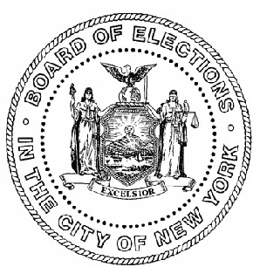Party\Ind. Body
Name
Address
All Parties and Independent Bodies
Nominations for the following offices and positions:
Member of the City Council
Page 2 of 3

THE CONTEST LIST
Special Election 44th Council - 03/25/2025
Kings All Parties and Independent Bodies
TENTATIVE
SUBJECT TO CHANGE

BOARD OF ELECTIONS
IN THE CITY OF NEW YORK
PRINTED AS OF:
2/4/2025 1:59:50PM
Party\Ind. Body
Name
Address
Member of the City Council - 44th Council District, # to be elected: 1
1171 Ocean Parkway 5C Brooklyn, NY 11230
Simcha Felder
Simcha
4316 17 Avenue Brooklyn, NY 11204
Heshy Tischler
Team Trump
Page 3 of 3

